Date:31/10/2023

Project ID:proj_223338_Team_4

Project Title:Noise pollution monitoring

**Noise pollution monitoring**

**Phase 5**

**Noise Pollution Monitoring Objectives:**

**The objectives of noise pollution monitoring typically include:**

**Assessment of Noise Levels:** Measuring and analyzing noise levels in different areas to understand the extent of noise pollution.

**Identification of Sources:** Determining the primary sources of noise pollution in a given location, such as traffic, industrial activities, or construction.

**Compliance with Regulations:** Ensuring that noise levels comply with local, national, or international regulations and standards.

**Impact on Health:** Assessing the potential health impacts of noise pollution on the community, such as hearing damage, sleep disturbances, and stress.

**Identification of Hotspots:** Identifying areas with exceptionally high noise levels, which may require targeted interventions.

**Long-term Trends:** Monitoring noise levels over time to identify trends and evaluate the effectiveness of noise reduction measures.

**Public Awareness:** Raising awareness among the public and policymakers about the importance of noise pollution control.

**Policy Development:** Providing data to support the development of noise control policies and regulations**.**

**Noise Mapping:** Creating noise maps to visualize noise pollution spatially and plan urban development accordingly.

**Community Engagement:** Involving the community in noise monitoring and mitigation efforts, such as citizen science initiatives.

**IoT Noise Monitoring Setup:**

Setting up an IoT (Internet of Things) device for noise pollution monitoring involves several key steps:

**Selecting Sensors:** Choose appropriate noise sensors, such as microphones or sound level meters, capable of measuring sound levels in decibels (dB).

**Hardware Selection:** Pick suitable microcontrollers or single-board computers (e.g., Arduino, Raspberry Pi) to process sensor data and connect to the internet.

**Power Supply**: Ensure a reliable power source for your IoT device, which can be battery-powered or connected to a constant power supply, depending on the deployment location.

**Connectivity**: Establish a means for the device to transmit data. This can be through Wi-Fi, cellular, LoRa, or other IoT-specific networks.

**Data Processing**: Develop or configure software on the microcontroller to process the sensor data, filter noise, and convert it to meaningful information (e.g., average noise levels over time).

**Data Storage**: Set up a cloud-based or on-premises database to store the collected noise data securely.

**Data Transmission**: Use protocols like MQTT or HTTP to transmit data from the device to your chosen data storage and analysis platform.

**Visualization**: Create a user-friendly interface (web or mobile app) to visualize the noise data, allowing real-time monitoring and historical analysis.

**Alerts**: Implement alerting mechanisms to notify relevant parties when noise levels exceed predefined thresholds.

**Power Management**: If using battery power, implement power-saving measures to extend the device’s operational life.

**Location Deployment:** Strategically place your IoT noise monitoring devices in areas of interest, such as urban centers, construction sites, or residential neighborhoods.

**Data Analysis**: Use data analytics tools to derive insights from the collected noise data, identifying trends and potential sources of noise pollution.

**Maintenance**: Regularly maintain and calibrate the sensors to ensure accurate measurements.

**Compliance**: Ensure that your noise monitoring system complies with local regulations and privacy laws.

**Data Security**: Implement security measures to protect the collected data from unauthorized access

**Noise Pollution Monitoring Platform:**

Developing a platform for noise pollution monitoring involves several key steps:

Sensor Selection: Choose appropriate sensors (e.g., microphones) capable of capturing noise data accurately. Consider factors like sensitivity and frequency range.

**Data Collection:** Develop hardware to capture noise data from the sensors. This may involve analog-to-digital converters and microcontrollers.

**Data Transmission:** Implement a method to transmit data to a central platform, which could be through wired or wireless connections.

**Data Storage:** Set up a database to store the collected noise data. Ensure it’s scalable, secure, and can handle large volumes of data.

**Data Analysis:** Develop algorithms to process and analyze the noise data. This can involve identifying noise patterns, measuring sound levels, and extracting relevant information.

**Visualization:** Create a user-friendly interface to display noise data, such as charts, maps, and real-time updates.

**Alerts and Notifications:** Implement a system to trigger alerts or notifications when noise levels exceed predefined thresholds.

**Integration:** Make the platform compatible with various devices and operating systems to ensure accessibility and usability.

**Machine Learning:** Consider implementing machine learning models for predictive analysis and anomaly detection.

**User Authentication and Security:** Ensure user data privacy and platform security through authentication and encryption.

**Regulatory Compliance:** Be aware of local noise pollution regulations and ensure the platform complies with relevant standards.

**Maintenance and Calibration:** Develop a maintenance plan to regularly calibrate sensors and update software.

**Community Engagement:** Consider involving the community in noise monitoring efforts, as they can provide valuable data and insights.

**Data Sharing:** Enable data sharing and collaboration with researchers, local authorities, and the public to address noise pollution collectively.

**Feedback Loop:** Create a mechanism for users to report noise disturbances and provide feedback, improving the platform’s effectiveness over time.

**Noise Pollution Monitoring in Python:**

Monitoring noise pollution typically involves measuring sound levels at various locations. Here's a high-level overview of how you can implement noise pollution monitoring using Python and common sensors like a sound level meter (SLM) or a microphone:

**Hardware Setup:**

Connect a sound level meter or a microphone to your computer or microcontroller (e.g., Raspberry Pi or Arduino).

**Python Libraries:**

Use Python and relevant libraries for data collection and analysis. You may need to install packages like sounddevice, numpy, matplotlib, and pyaudio.

**Data Collection:**

Capture sound data using your microphone. You can use libraries like sounddevice or pyaudio to record audio.

Python

Copy code

Import sounddevice as sd

Def audio_callback(indata, frames, time, status):

# Process audio data here

Sd.default.samplerate = 44100 # Set the sample rate

With sd.InputStream(callback=audio_callback):

Sd.sleep(duration) # Record audio for a specific duration

**Data Analysis:**

Analyze the recorded audio to calculate sound levels in decibels (dB). You can use Fast Fourier Transform (FFT) or other signal processing techniques to convert the audio data into a frequency domain.

Python

Copy code

Import numpy as np

Def calculate_sound_level(audio_data):

# Convert audio data to dB

Db = 20 * np.log10(np.max(np.abs(audio_data)))

Return db

Logging and Visualization:

Log the sound levels over time and create visualizations like real-time graphs or historical data plots.

Python

Copy code

Import matplotlib.pyplot as plt

Def plot_sound_levels(time, sound_levels):

Plt.plot(time, sound_levels)

Plt.xlabel(‘Time’)

Plt.ylabel(‘Sound Level (dB)’)

Plt.show()

**Threshold Monitoring**:

Set thresholds for noise pollution levels and trigger alerts or actions when these thresholds are exceeded.

**Data Storage:**

Store data in a database or a file for further analysis and reporting.

**Real-time Monitoring:**

For real-time monitoring, you can continuously capture and process audio data and update your visualizations.

**Remote Access (optional):**

If you want to access data remotely, you can create a web interface or an API using frameworks like Flask or Django.

**Notification System (optional):**

Integrate a notification system to alert relevant authorities or stakeholders when noise pollution levels exceed predefined limits

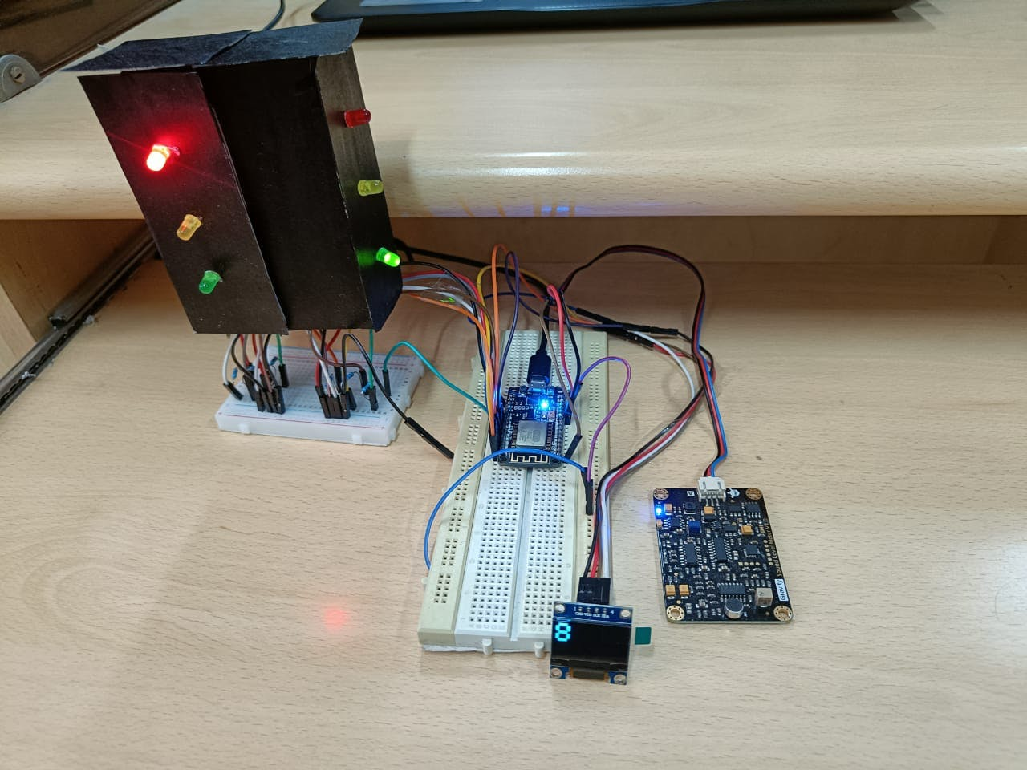**IoT in Noise Monitoring**

**In the context of noise pollution monitoring, IoT (Internet of Things) refers to the use of interconnected devices and sensors to collect, transmit, and analyze data related to noise levels in the environment. Here’s a breakdown of how IoT is applied in noise pollution monitoring:**

**Sensors:** IoT devices are equipped with specialized noise sensors or microphones that can detect and measure sound levels in decibels (dB). These sensors can be placed in various locations throughout an area to capture noise data.

**Data Collection:** The sensors continuously collect noise data from their surroundings. This data includes information about the intensity, frequency, and duration of noise events.

**Data Transmission:** The collected noise data is transmitted over the internet to a central server or cloud-based platform. This allows real-time or near-real-time monitoring and analysis.

**Data Storage and Analysis:** The noise data is stored in a database and can be analyzed to identify patterns, trends, and potential noise pollution sources. Advanced algorithms can help differentiate between different types of sounds, such as traffic noise, industrial machinery, or human activity.

**Visualization:** Users, such as environmental agencies or researchers, can access the data through web-based dashboards or mobile apps. Visual representations like graphs, maps, and charts make it easier to understand noise levels over time and across different locations.

**Alerts and Notifications:** IoT systems can be programmed to trigger alerts or notifications when noise levels exceed predefined thresholds. This allows for rapid response to noise pollution incidents.

**Historical Data and Reporting:** IoT systems store historical noise data, which is valuable for long-term analysis and regulatory reporting. It can be used to assess the effectiveness of noise reduction measures and policies.

**Integration with Other Systems:** IoT noise monitoring systems can be integrated with other environmental monitoring technologies, such as air quality sensors, weather stations, and traffic cameras, to gain a more comprehensive understanding of the factors contributing to noise pollution.